Forms Validation and Avatar Upload
Technical Formative Assessment 3 | SimplePOS Customer and User Accounts
Angelo Kacey N. Pineda • Section TW33 • IT0049 Web System Technologies
This document describes the TFA3 work added to the existing CodeIgniter POS project: validated customer and user forms, editable account records, and display-ready user avatars. It also gives the local setup steps and points to the repository. The public hosting URL is intentionally pending.

Assessment requirements
Requirement from the activity | Project implementation
Create customer form at /customers/new | POST is validated before insert. Required names, email and phone are checked; invalid input is redisplayed with messages and values.
Create user form at /users/new | Username is required, alphanumeric, 4–50 characters and unique. Full name, valid unique email, password, role and status are validated.
Edit customer and user records | Edit routes load the record by route ID, prefill form fields and update only allowlisted values. Existing username/email are allowed while duplicates are rejected.
Upload an avatar from the user edit page | Only successful JPG/PNG uploads at or below 2 MB are accepted using server-detected MIME type. The image is resized/cropped to a 320 × 320 JPG with a random filename.
Save filename and display image | Only the generated basename is stored in user_accounts.avatar. The Users listing displays it or the SVG placeholder.
Repository and hosted application | Repository link is included below. Hosting is not configured yet, at the user’s direction; add the public URL after deployment.

Form validation and safe handling
All writes run through CodeIgniter validation on the server. Text input is trimmed, emails are lowercased, and customer address may be left blank. Customer email, user username, and user email have both application uniqueness checks and database unique indexes. Route IDs select the row being edited; the forms do not use a hidden ID to decide which record to update.
- The user form saves a password hash, never the submitted password. A blank password on edit leaves the existing hash unchanged.
- Role and status values are checked against fixed server-side allowlists. CSRF protection is included on forms.
- Views escape displayed account data. Model writes contain explicit fields rather than the full request payload.
- The avatar filename is generated by the application. Upload errors, invalid MIME types, and files above 2 MB produce an error on the edit form.

Routes and files
Route | Use
/customers | List customer accounts
/customers/new | Create a customer
/customers/edit/{id} | Edit an existing customer
/users | List accounts with avatar or placeholder
/users/new | Create a user account
/users/edit/{id} | Edit account and optionally replace avatar

Controllers are in app/Controllers/Customers.php and Users.php. Models are in app/Models/CustomerModel.php and UserModel.php. Forms and listings are in app/Views/customers and app/Views/users. Avatar files are served from public/uploads/avatars; the fallback image is public/images/avatar-placeholder.svg. The POS database export is database/pos_database.sql.

Database and local setup
- Start Apache and MySQL in XAMPP. For a fresh database, import database/pos_database.sql in phpMyAdmin. The export drops and recreates POS tables; back up data first.
- Copy env to .env and set database.default.database = pos_database with the local database credentials.
- Run composer install, then C:\xampp\php\php.exe spark serve. Open http://localhost:8080.
- For an existing TFA2 database, do not reimport the destructive export. Run: ALTER TABLE user_accounts ADD COLUMN avatar VARCHAR(255) NULL AFTER account_status;
- Enable PHP GD and allow the web-server process to write to public/uploads/avatars. Configure production document root to public/ and disable script execution in the upload directory.

Submission links
Item | Status
GitHub repository | https://github.com/Angelowww11/TA1_CodeIgniter
Hosted application | Pending deployment. A PHP-capable host and public URL have not been provided; GitHub Pages cannot execute CodeIgniter/PHP.

The README.md contains the setup and feature summary, and HOSTING.md lists deployment steps. The screenshots in this appendix and evidence/screenshots record the completed local workflows. The hosted application link remains pending as requested.

Technical references
CodeIgniter 4 User Guide: Validation — https://codeigniter4.github.io/userguide/libraries/validation.html
CodeIgniter 4 User Guide: Working with Uploaded Files — https://codeigniter4.github.io/userguide/libraries/uploaded_files.html

Application screenshots
Screenshots were captured from the running local CodeIgniter application and phpMyAdmin. Temporary test records used for evidence were removed after capture.

Customer workflows
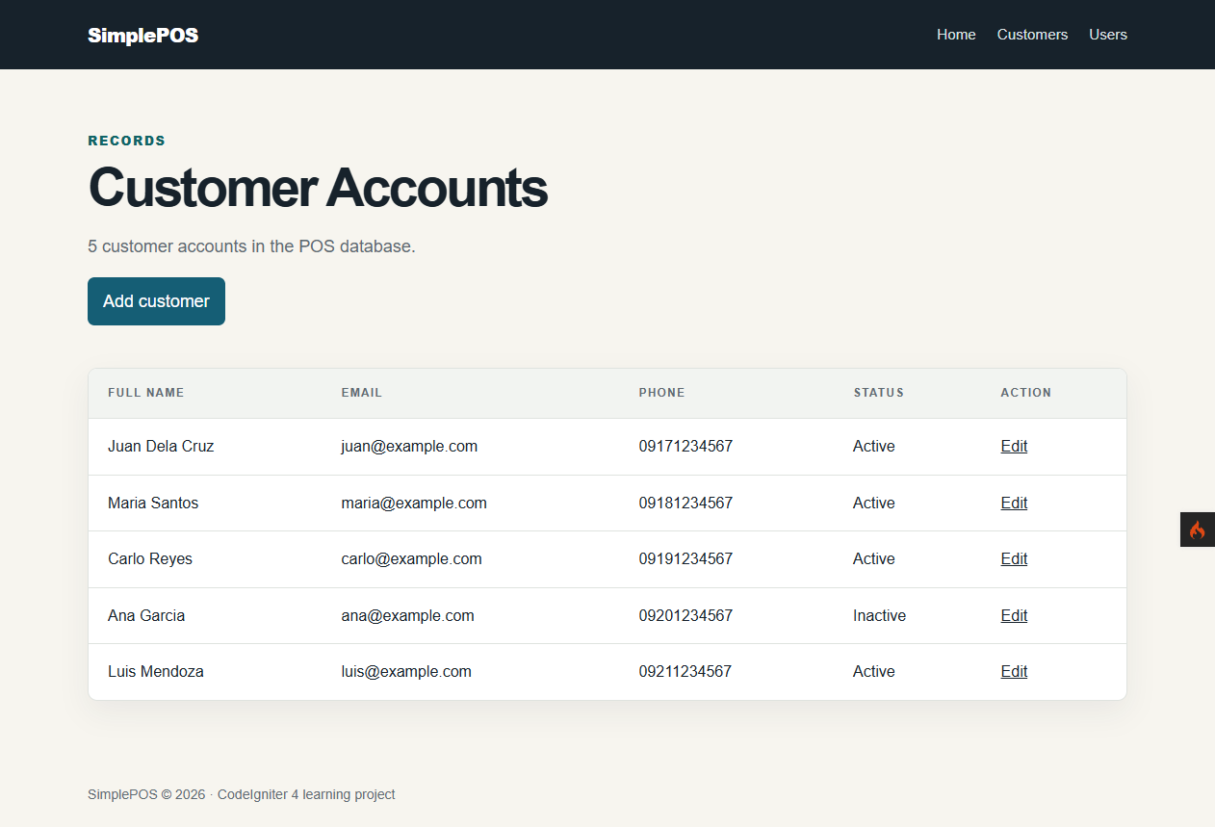  Customer account listing | 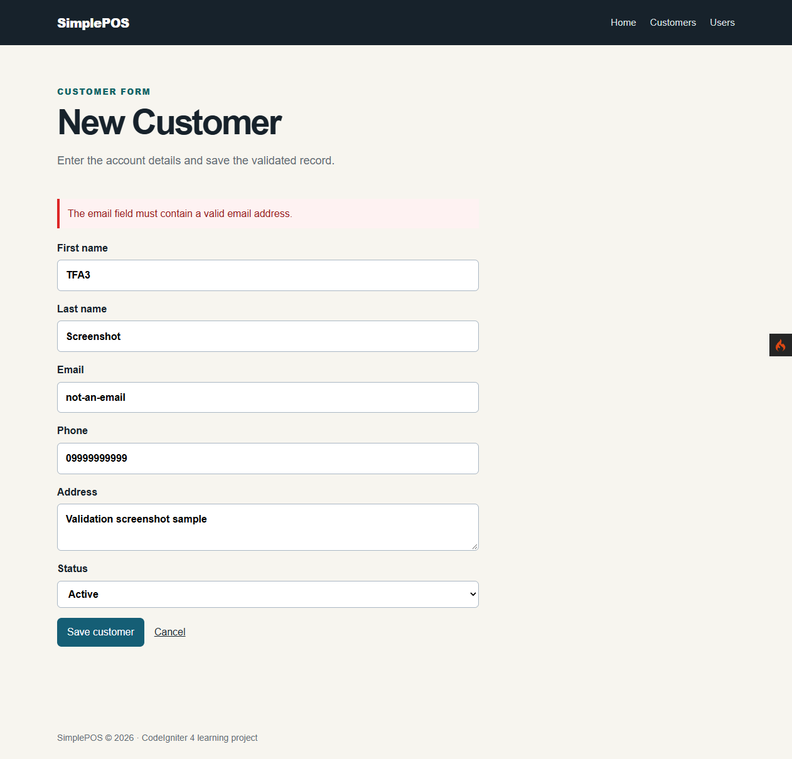  Invalid email rejected with entered values retained
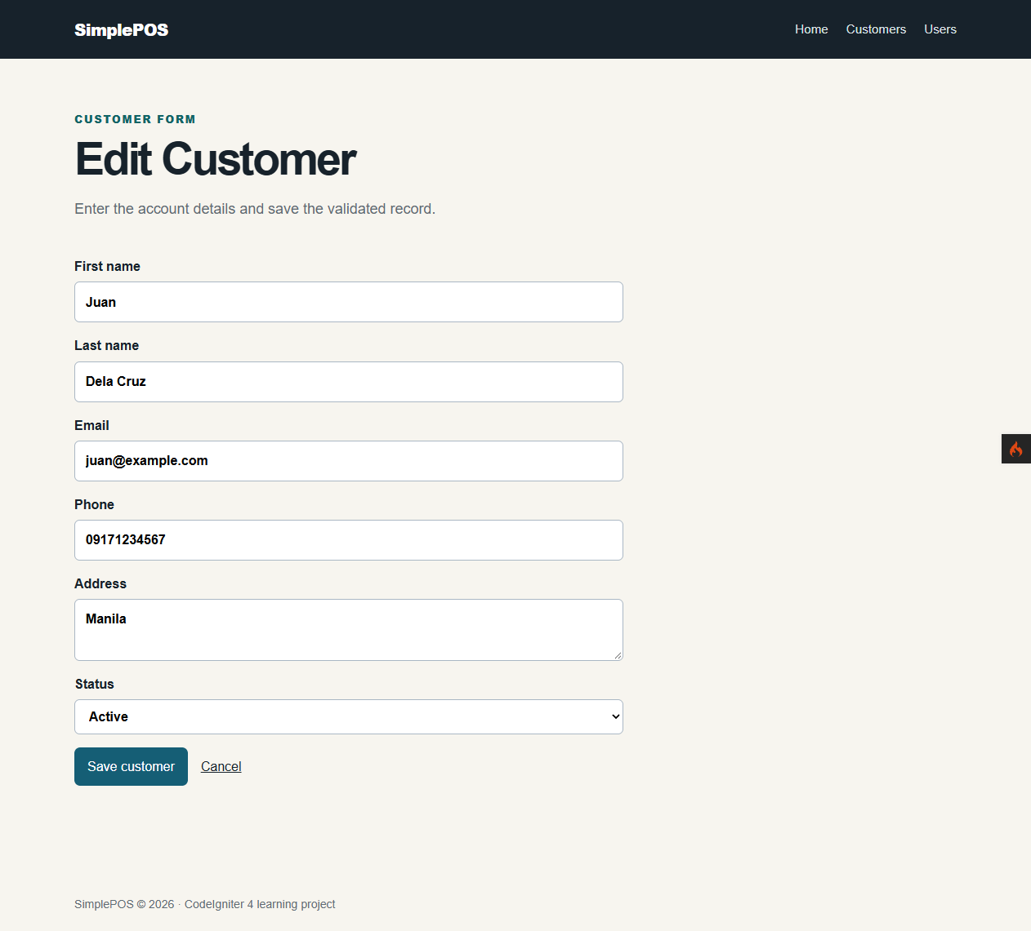  Customer edit form prefilled from an existing record | 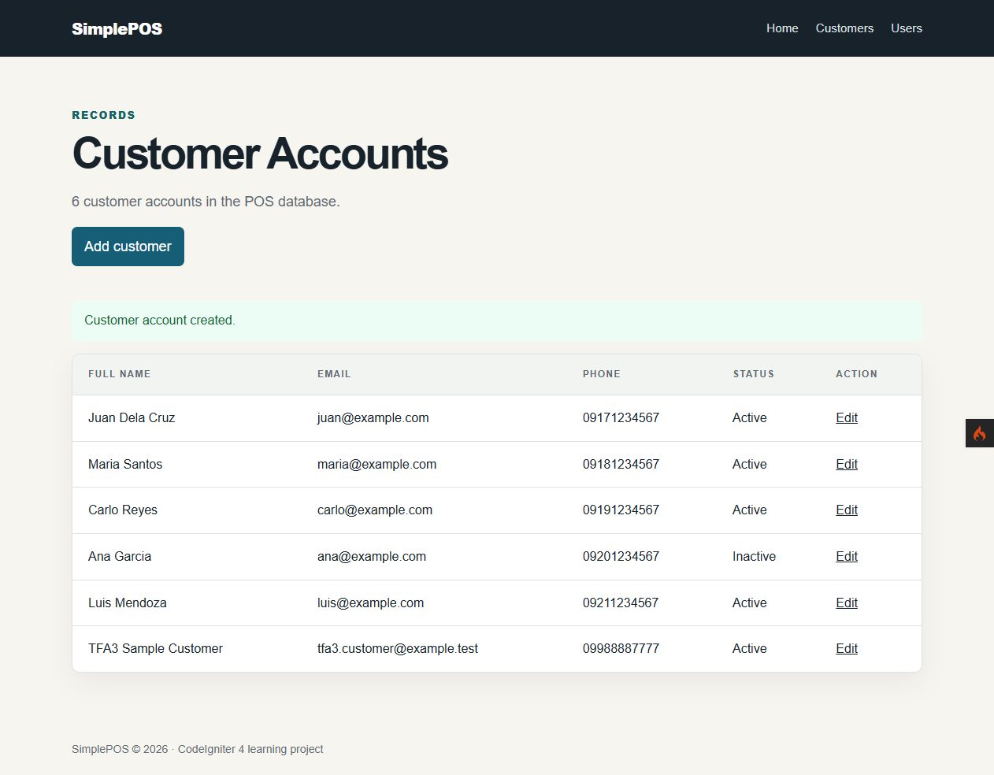  Successful customer creation in the listing

User account forms
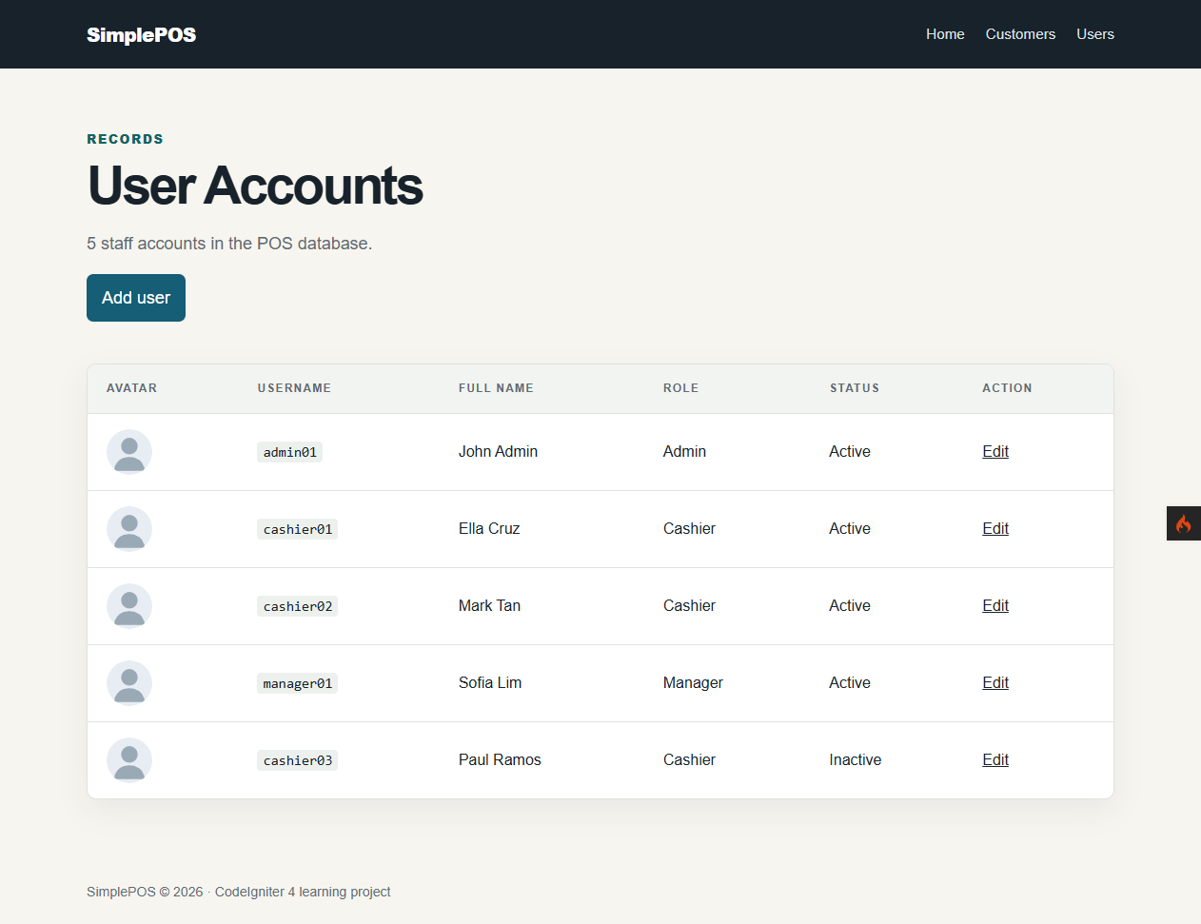  User listing with placeholder avatars | 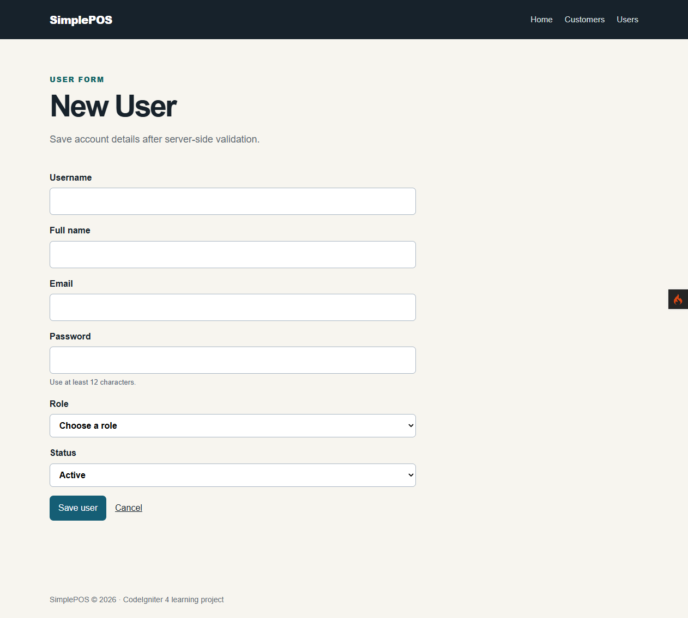  New user form
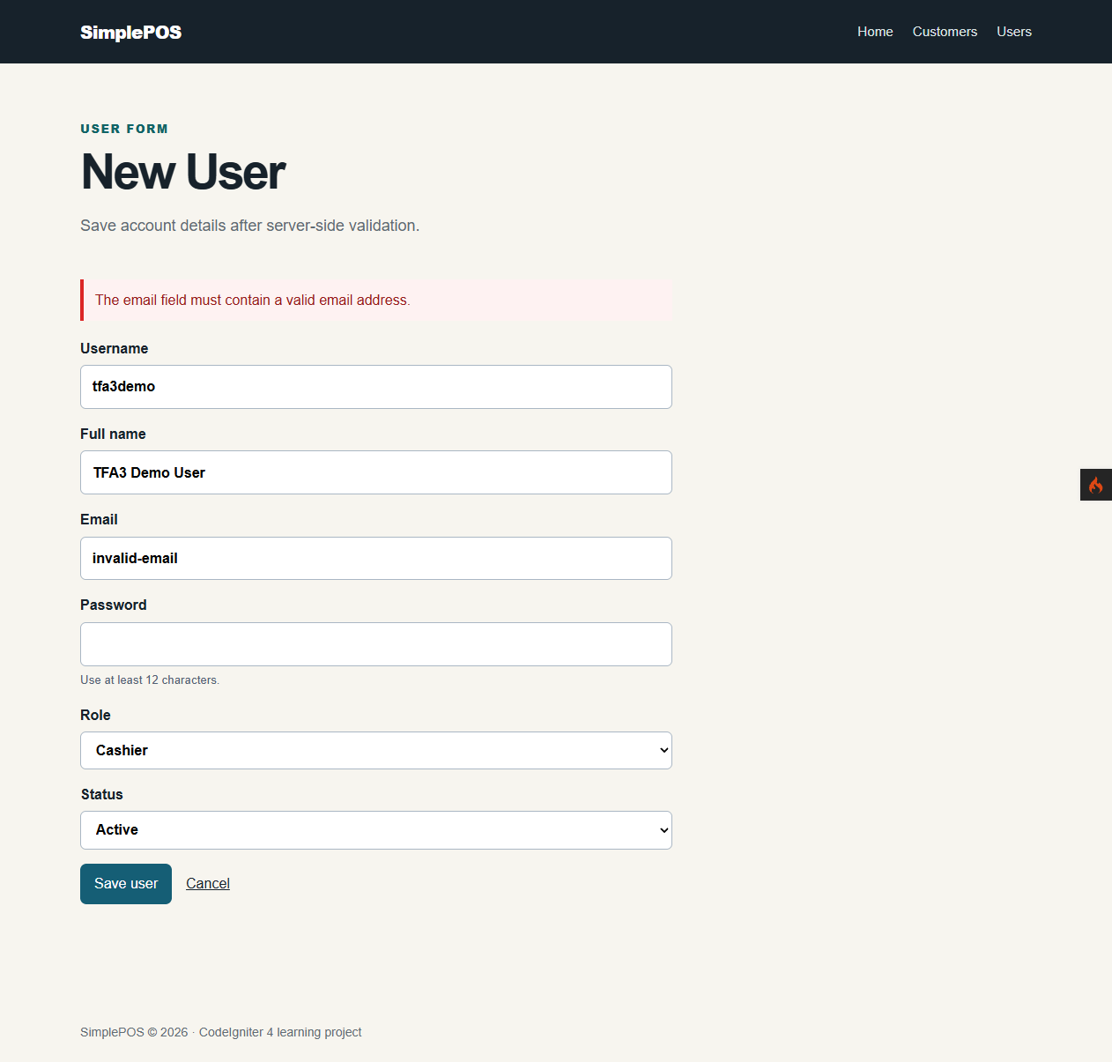  Invalid email rejected; account fields redisplayed | 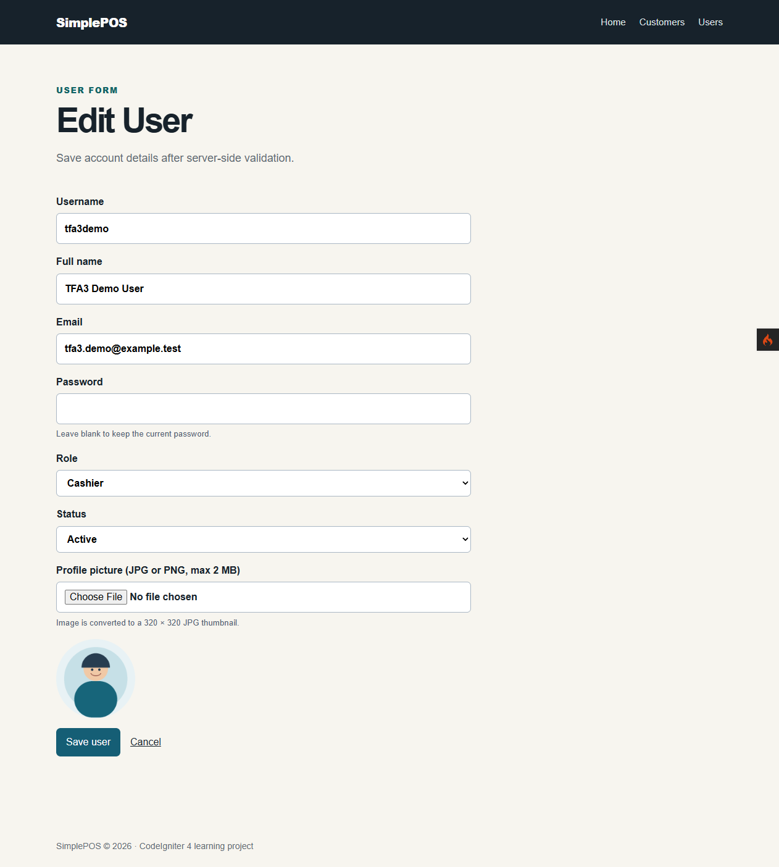  User edit form with profile picture input

Avatar upload and database
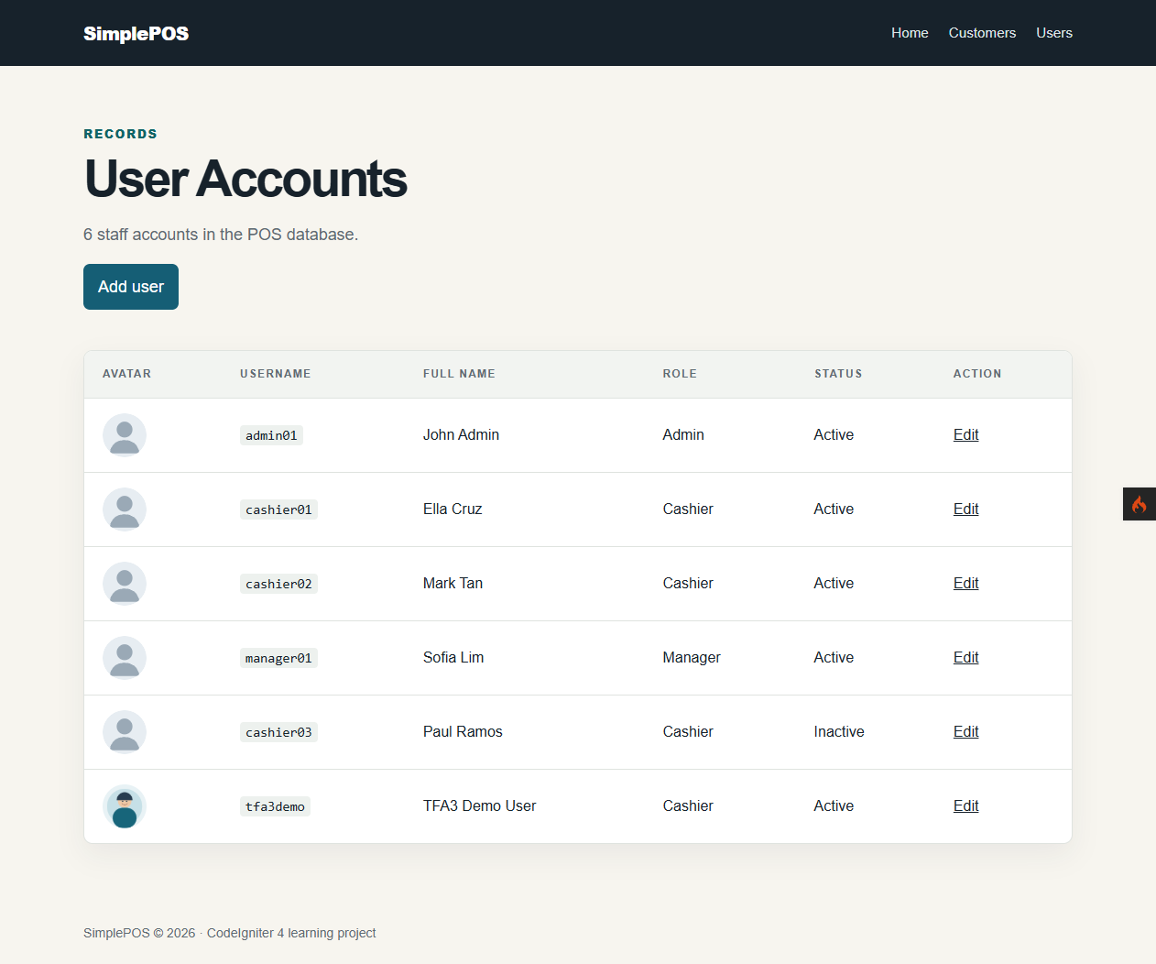  Prepared avatar thumbnail displayed in the user listing | 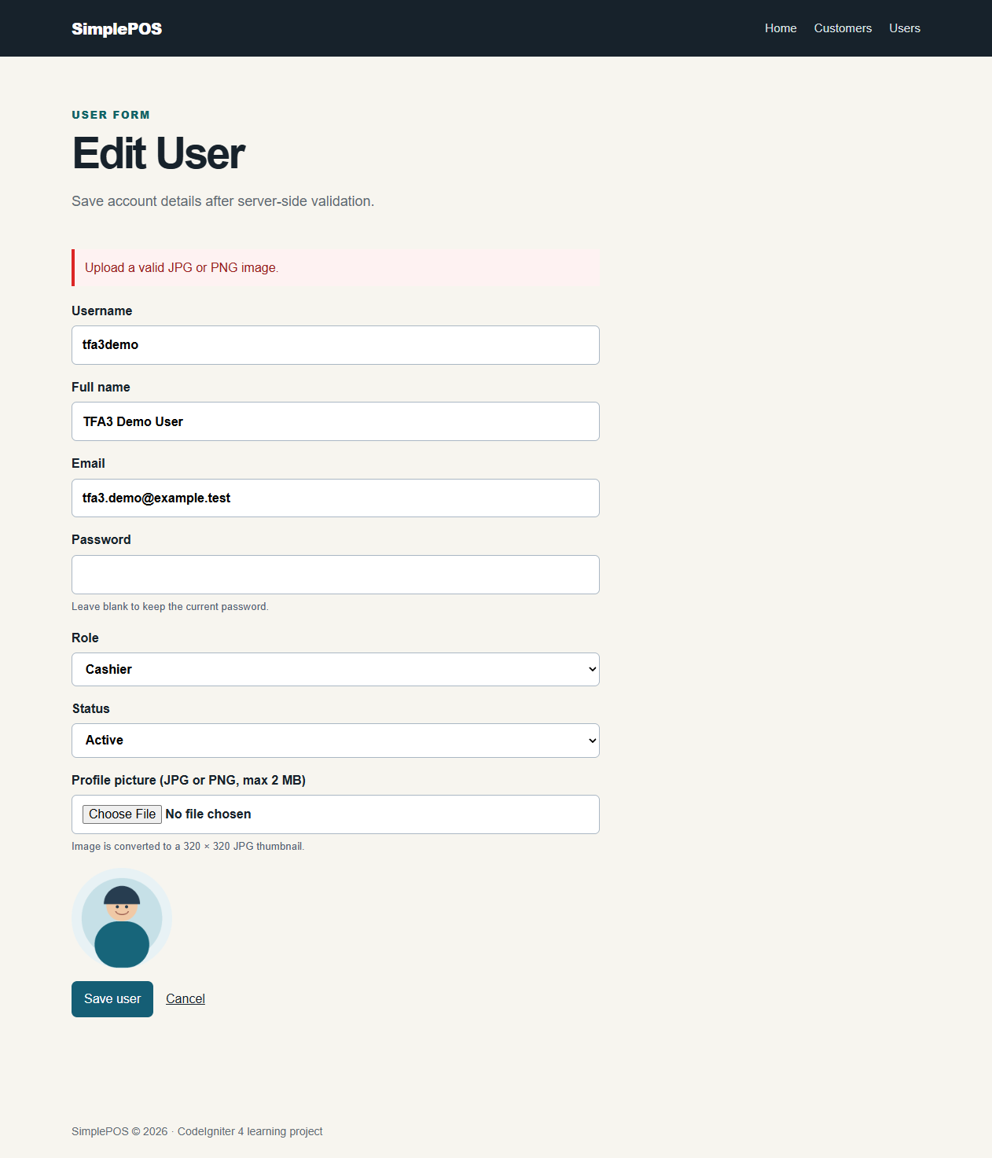  Unsupported SVG avatar rejected with a clear message
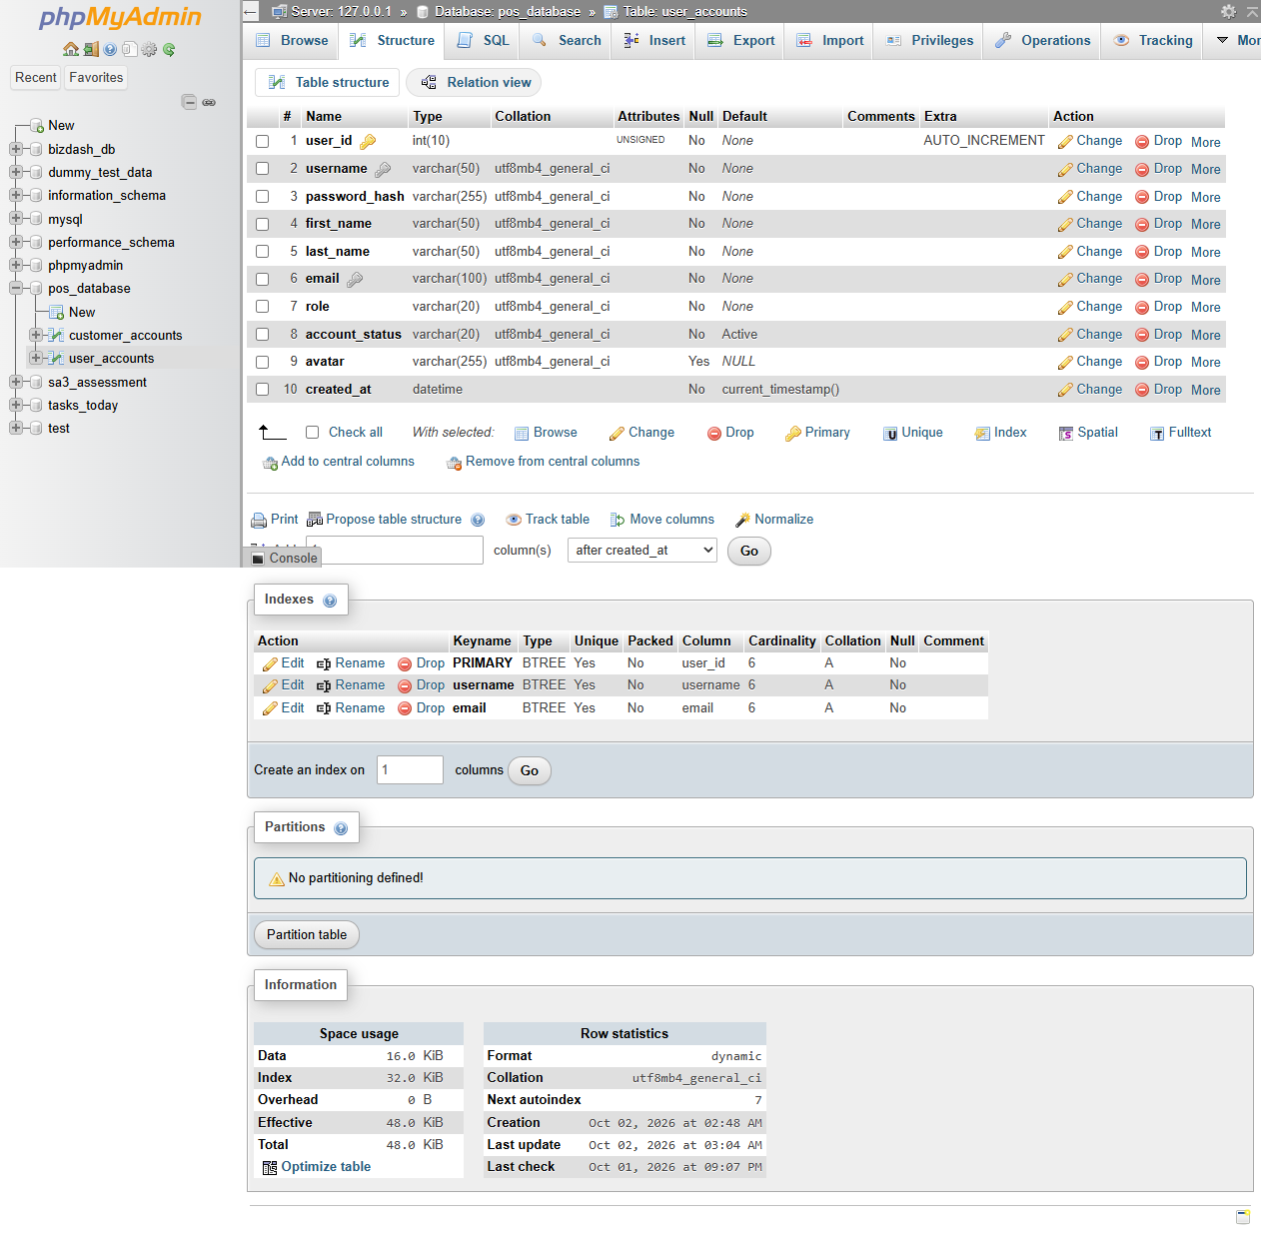  Nullable avatar filename column in user_accounts | 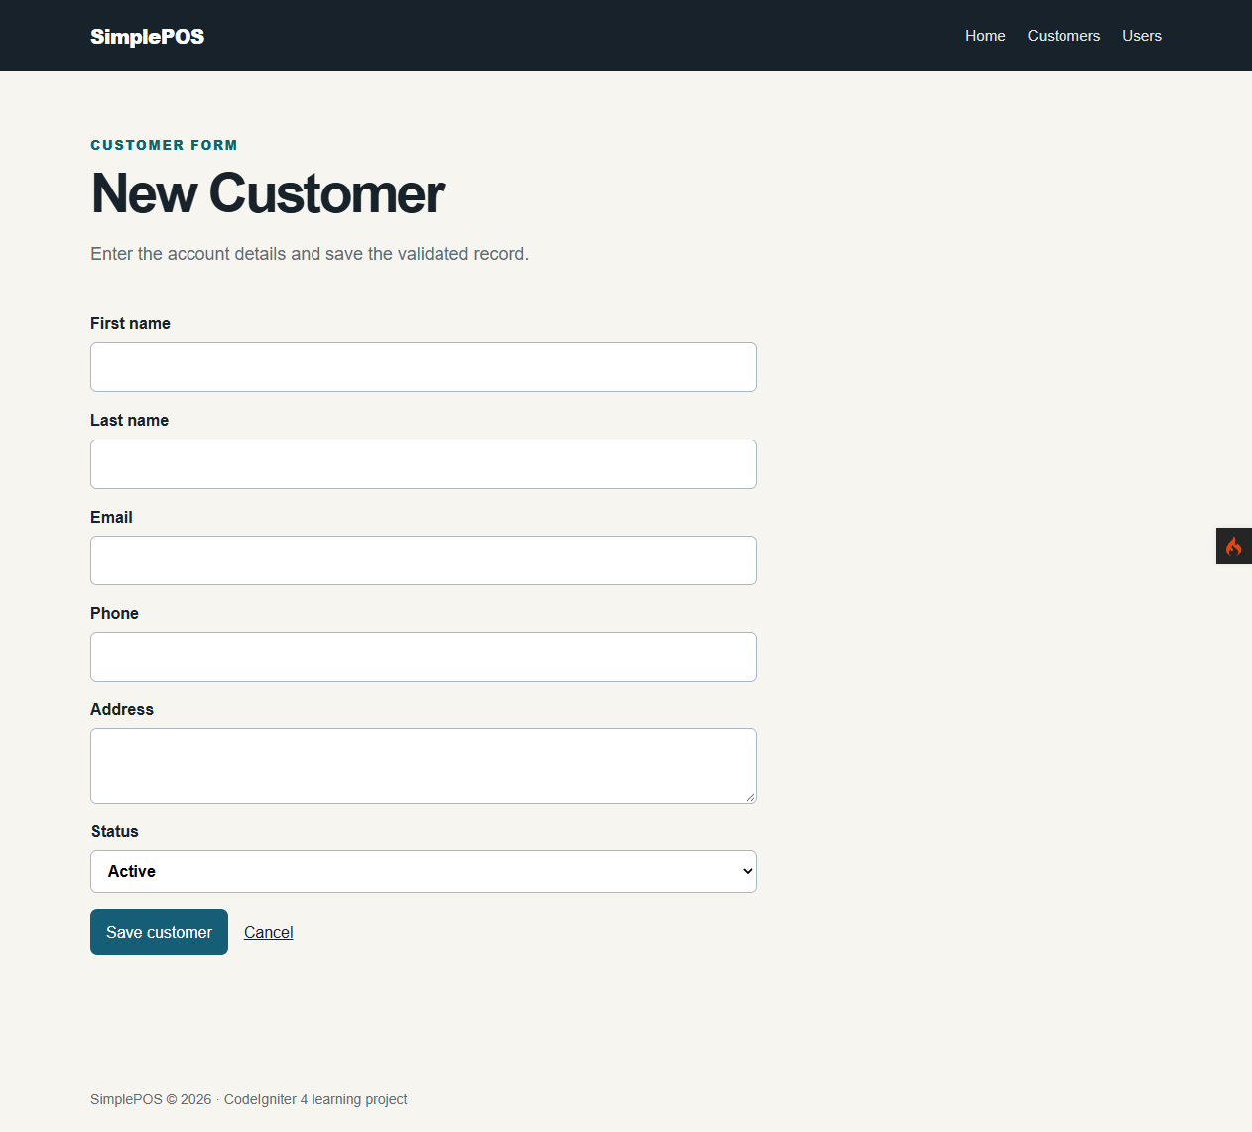  New customer form

